# DriverPass System Design Document

## UML Diagrams

### UML Use Case Diagram

### UML Activity Diagrams

Customer Makes a Reservation for a Driving Lesson

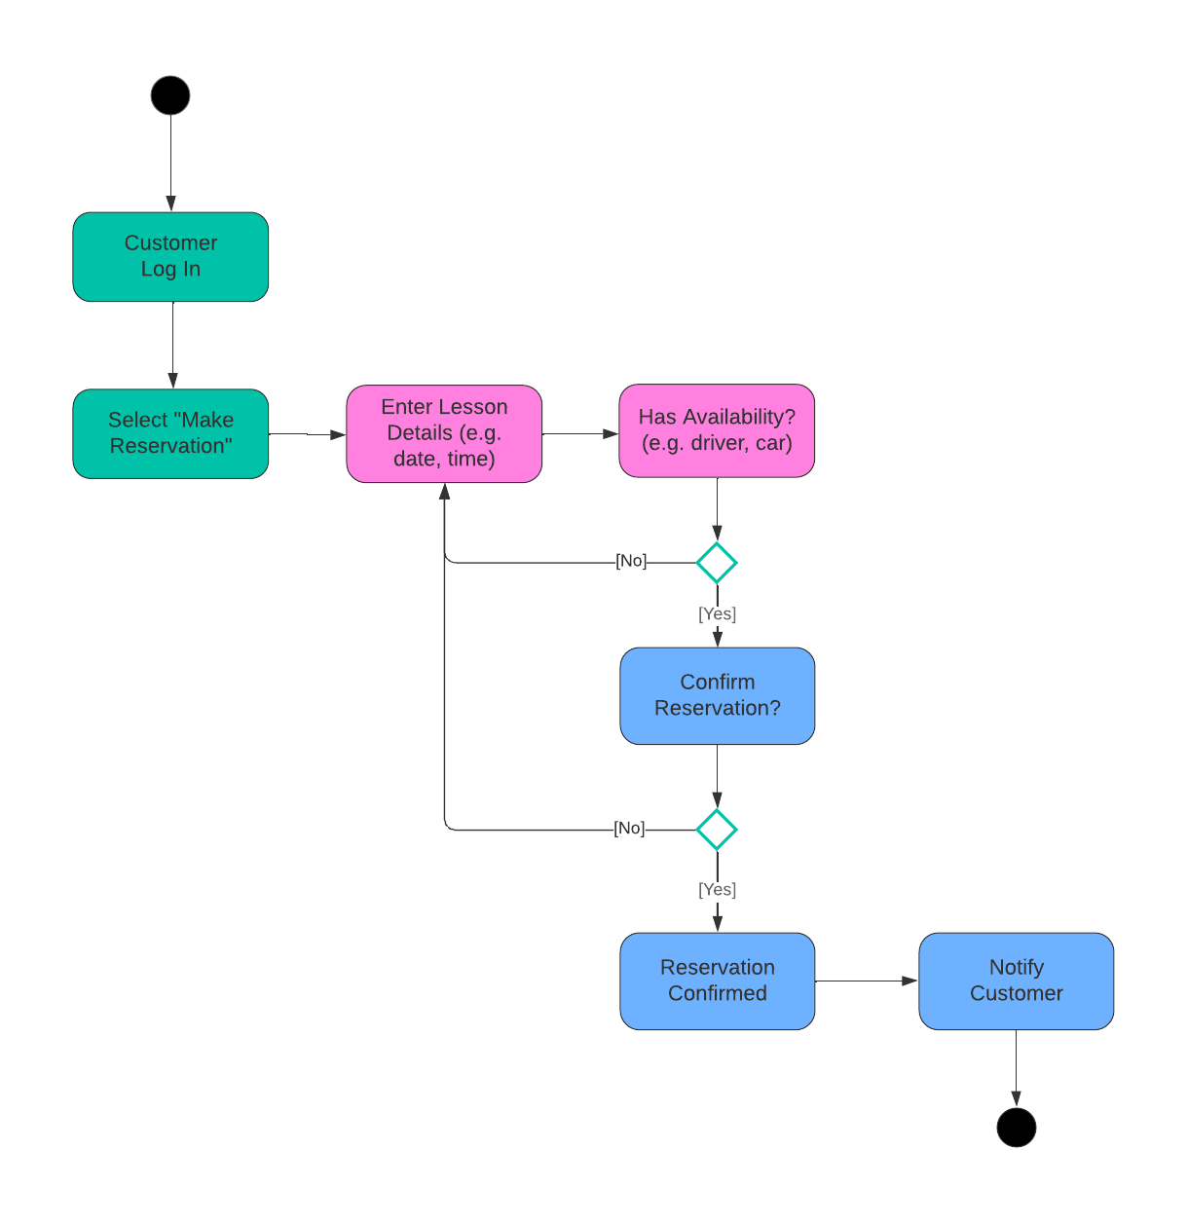

Admin Generates and Downloads a Report

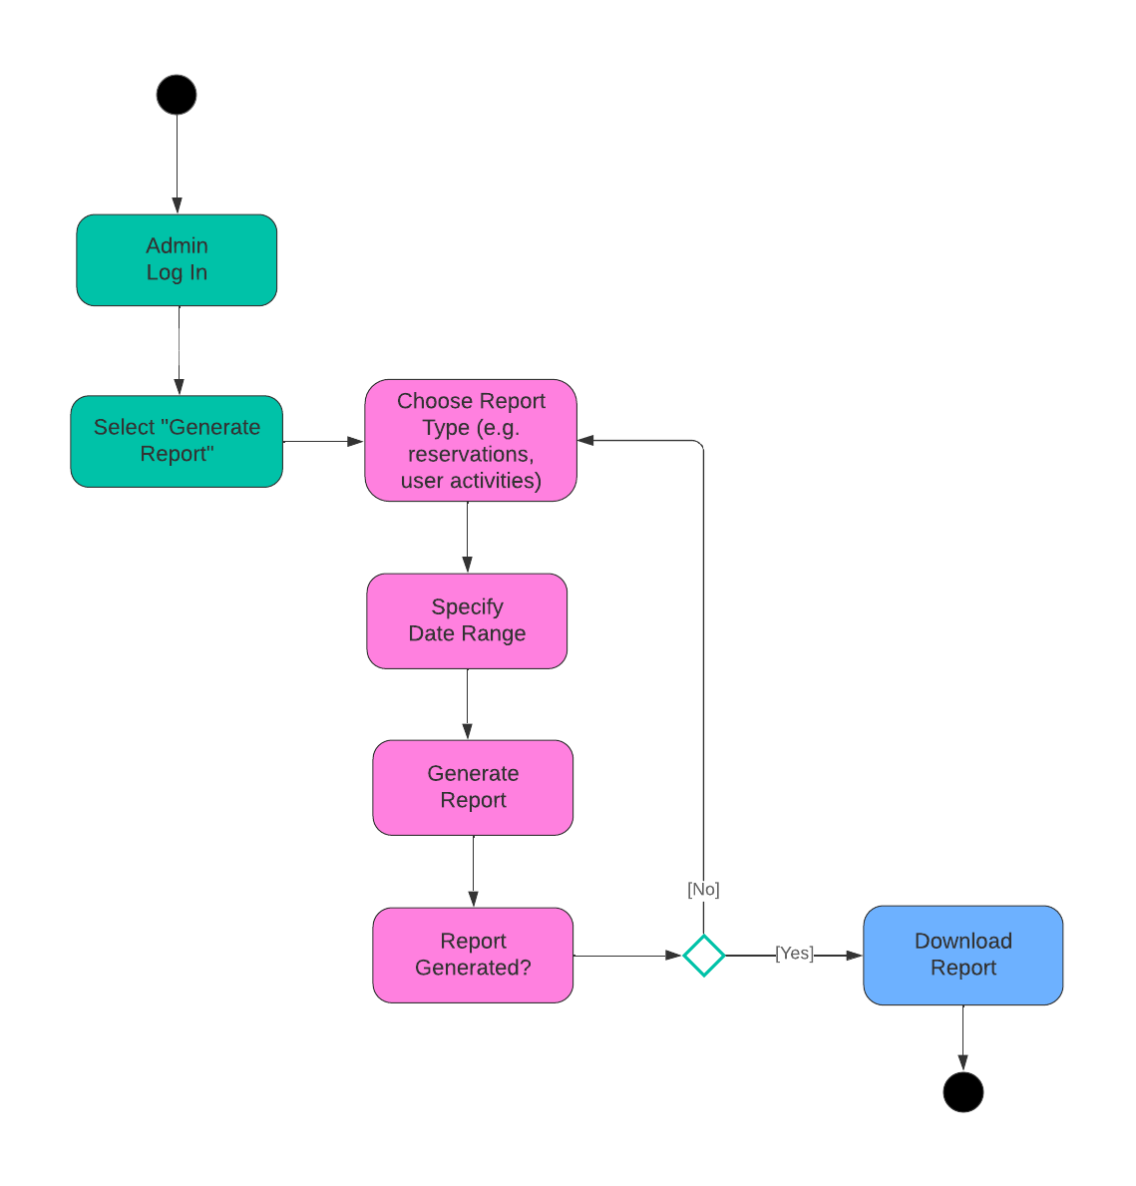

### UML Sequence Diagram

Customer Makes a Reservation for a Driving Lesson

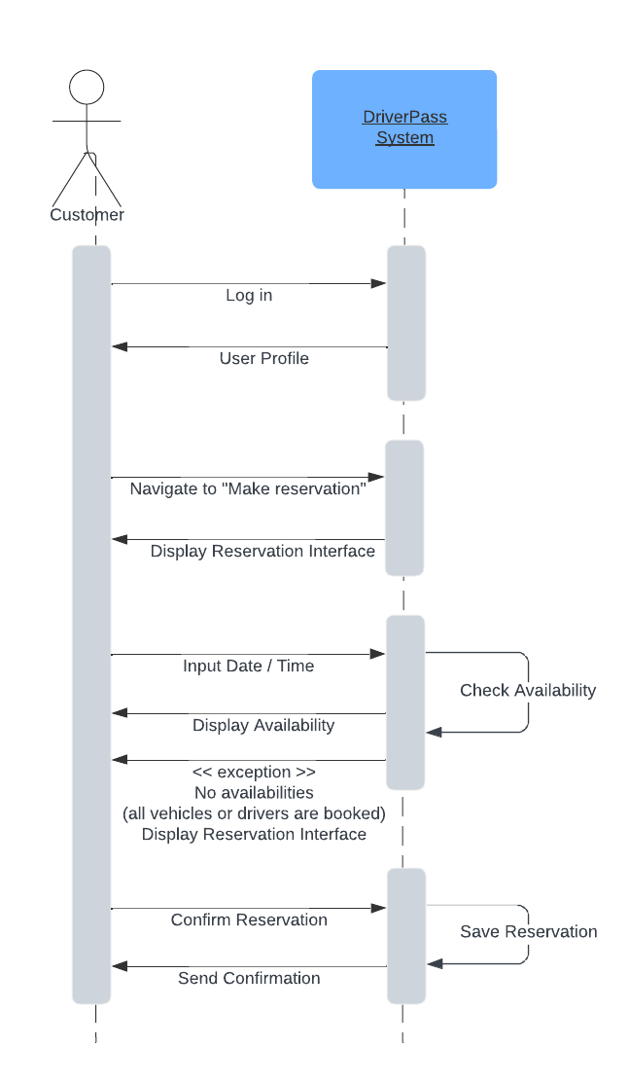

**UML Class Diagram**

A class diagram of the DriverPass System


## Technical Requirements

Based on the diagrams above, the technical requirements for the DriverPass system encompass hardware, software, tools, and infrastructure necessary for the application to operate.

Hardware Requirements

* Cloud-based servers for hosting the web application and database. Servers should have high availability and scalability to handle varying loads, especially during peak usage times.
* Desktop computers, laptops, and smartphones for users to access the system. Devices should have internet connectivity and modern web browsers.

Software Requirements

* Developed using web technologies such as HTML, CSS, JavaScript, and a frontend framework like React or Angular for responsive and dynamic user interfaces.
* Backend services implemented using a robust server-side technology like Node.js, Python (Django or Flask), or Java (Spring Boot).
* A relational database like PostgreSQL or MySQL for handling user data, reservations, and driving lesson notes.
* Implement industry standards and secure authentication mechanisms.

Tools and Infrastructure

* A reliable cloud service provider for hosting the application and database.
* Cloud services for backup, recovery, and security compliance.
* Use version control systems for source code management.
* Deployment pipelines for automated testing, building, and deployment for the application.
* Logging tools for tracking system activities and troubleshooting issues.
* Integration with external services such as the DMV for updating rules and policies. For example, RESTful APIs for communication between the DriverPass system and the DMV service.

These technical requirements ensure the DriverPass system is robust, secure, and scalable, capable of handling the demands of its users.